Small Business Administration (SBA) Disaster Loans to Help Working Capital Needs
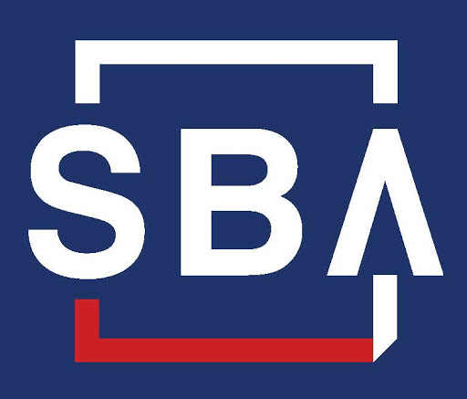
Do you run a small business or know someone who does? Many of my friends who own stores and restaurants have noticed a drop in customers and have had to adapt the way they do business (Jan).

What resources exist that may be of benefit to Kansas' small businesses?

The President has authorized the SBA to provide low-interest loans directly to businesses to help offset the dip in cash flow (revenues) or other economic impact (supply chain costs, etc.) caused by the COVID-19 disruption. For this reason, the disaster loans to businesses are called Economic Injury Disaster Loans (EIDL) and these federal loans are designed to help negatively impacted organizations cover their monthly expenses - including commercial loan payments - in order to stay in business during this crisis. Click HERE to read the latest SBA Press Release.

The State of Kansas is collecting documentation from businesses impacted by the COVID-19 crisis to support its request to the SBA for an Economic Injury Disaster Loan Declaration.

Negatively impacted businesses should go to http://www.ksready.gov/ to complete the SBA Estimated Disaster Economic Injury Worksheet For Businesses as soon as possible.
• When completing the form, businesses will need to indicate their County in the address section of the worksheet, and describe what adverse economic effects the COVID-19 crisis has had on the business in the Estimated Adverse Economic Impact section. Please specify the amount of diminished sales, supplier disruption, or other negative impacts from Jan. 31st until now. The form will need to be printed, completed, then scanned and emailed to amy.selm@ks.gov at the Kansas Department of Commerce.

Once the disaster declaration for Kansas is finalized, small businesses in the state will be able to apply for assistance in the form of Economic Injury Disaster Loans (EIDL). Affected businesses and private nonprofit organizations may then go to www.sba.gov/disaster and click on the “Apply for Assistance” button and then click on “Eligible Disaster Areas”. Select “Kansas” and your county. The most recent declaration will be at the top and that’s where you’ll find information on the COVID-19 EIDL Loans and be able to apply.

The SBA also has a webpage that encompasses all of the information we have available for Small Business related to COVID-19. We encourage you to check it out: Guidance for Businesses and Employers to Plan and Respond to Coronavirus Disease 2019 (COVID-19) - https://www.sba.gov/page/guidance-businesses-employers-plan-respond-coronavirus-disease-2019-covid-19 - Jan Steen, K-State Research and Extension PRIDE, jmsteen@ksu.edu

