Walk Kansas 2022 March 27 – May 21

Team Registration Instructions

Ready to register your team for Walk Kansas? Here is a step-by-step guide.

- Form a team of 4-6 people. Six (6) is ideal and if you have less than 6, each person will have to work a little harder to reach your team goal. (That really isn’t a bad thing, right?)
- Choose a team campaign. The rest of these are instructions are for you, the captain, as you are the one to get this process started.
- Select a team name. This is your chance to be creative and fun! Here is an example: “Cheaper Than Therapy” (because it is 😉)
- Together with your team-mates, choose a challenge ---- a goal you want to work toward. Here are the options:
  - 8 Wonders of Kansas trail: This option requires each person get at least 2 ½ hours of moderate activity/week, the minimum recommended amount of physical activity determined by Physical Activity Guidelines for Americans. This trail is 480 miles and you’ll learn about the 8 wonders of Kansas as you go!
  - Cross Country trail: You’ll start in the NE corner and end in the SW corner of Kansas. This requires each person to get 4 hours of moderate activity/week and the team would travel 768 miles.
  - Little Balkans to Nicodemus trail: Explore the SE region of Kansas before heading NW to historic Nicodemus. This challenge requires each member to get 6 hours of moderate activity/week, with the team traveling 1152 miles.
- After you choose a team challenge from the options above, gather each team member’s name and email address. Now you are ready to register!

Go to www.walkkansas.org
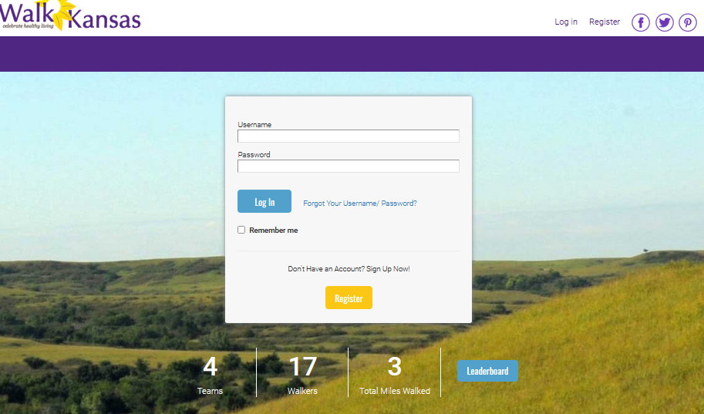
Click “Register Now” below the purple bar.
The next screen takes you to the online system.
Click the Yellow “Register” button.

