Soil Testing Procedure

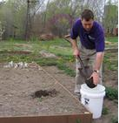
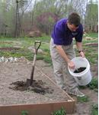
1. Use a soil probe, spade or shovel to collect the soil samples to a depth of 4-8 inches (or as deep as the roots of the crop you are growing). It is important to obtain a representative sample of the soil in the root zone. NOTE: Samples for the lawn should be taken to a depth of 4 inches; root crops like potato 8 inches.

2. It is generally advisable to take several samples (at least 6-8) around your garden or lawn, then combine these in a clean bucket or pail. This gives a representative sample of the entire growing area.

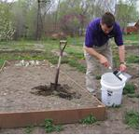
3. From the bucket or pail, select 1 cup to 11/2 cups of soil. Put the samples in a plastic bag that can be sealed (example 1qt Ziploc bag).

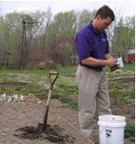
4. Make sure to label the bag with your name, address and include information on the crops grown (i.e., fescue, potato, apple). If you send more than one sample, be sure to identify each clearly.

5. Bring sample(s) to Wyandotte County K-State Research and Extension Office, located at 1216 N 79th St., Kansas City, KS 66112 between 8 am and 4:30 pm. WE ARE CLOSED 12:30 – 1:30 p.m. for lunch. Phone 913-299-9300 or email jo1@ksu.edu . Our website www.wyandotte.ksu.edu also has information and forms needed.

Kansas State University Agricultural Experiment Station and Cooperative Extension Service K-State Research and Extension is an equal opportunity provider and employer.

Adapted from Riley County - K-State Research and Extension

